**Product Design**

|  |  |  |  |
| --- | --- | --- | --- |
| **Team:**  **Members:** | | Ctrl-Alt-Elite  Austin Hoffman,  Akash Patel,  Hadia Bilal,  Shawana Tahseen,  Timmy Akindunni | |
| ***Revision Number*** | ***Revision Date*** | | ***Summary of Changes*** | | ***Author(s)*** |
| *Initial* | *09/25/2023* | | *Initial Creation* | | Austin,  Akash,  Hadia,  Shawana, Timmy |
| *1.0* | *10/21/2023* | | *Fix class diagram, update design summary, clarify wireframe* | | Austin,  Akash  Hadia,  Timmy. |
| *2.0* | *11/11/2023* | | *Added color scheme* | | Hadia |

# Class Diagram(s)

# ER Diagram(s)

# User Interface Wireframe(s)/Screenshot(s)

# *Wireframe in Sprint 1

|  |  |  |
| --- | --- | --- |
|  |  |  |
| **1: Login Screen**  Purpose:  - User can login in the app by putting in information like email and password.  - New users can click on Signup to go to sign up for the app. | **2: Signup Screen**  Purpose:  - User can sign up for the app by creating a unique username, putting in a valid email and creating a password. | **3: Home Screen**  Purpose:  - User will land to home screen after logging in. They can access mood tracking, regular check-ins, and goals. |

|  |  |  |
| --- | --- | --- |
|  |  |  |
| **4: Menu**  - Helps access most of the screens in the app. | **5: Chat Screen**  - User can chat with the bot on chat screen. | **6: Goals Screen**  - User can write down goals for the future and access previously created goals. |

|  |  |  |
| --- | --- | --- |
|  |  |  |
| **7: Profile Screen**  Purpose:  - User can customize their profile by adding a photo, name, email and phone number. | **8: Conversation History Screen**  Purpose:  - User can access previous conversations based on the date of the conversation. | **9: Emotion History Screen**  Purpose:  - User can see their emotion history throughout the month.  - User can also see how they felt on a certain day based represented through emojis. |

|  |  |  |
| --- | --- | --- |
|  |  |  |
| **10: Password Reset Screen**  Purpose:  - User can reset their password. | **11: Settings Screen**  Purpose:  - User can select a language, adjust text size and choose theme (dark or light) based on their preferences. | **12: Check-in Screen**  Purpose:  - User can write down the emotion they are feeling (happy, sad, angry, etc.) and write down any notes to self. |

|  |
| --- |
|  |
| **13: Conversation History Screen**  Purpose:  - Once the user puts in information about their mood/emotion, the confirmation pop up appears to confirm mood check in. |

**Link Analysis:**

**Link Analysis Description:**

* Login Screen (1):
  + Login button à home screen (3)
  + Signup link text à Signup screen (2)
* Signup Screen (2):
  + Sign in link text à login screen (1)
* Home Screen (3):
  + Check in option takes to the Check in Screen (12)
  + Check in submit button takes to the Check in Confirmation popup Screen (13)
  + Lines on the top right corner of the Home Screen (3) takes to the Menu Screen (4)
* Menu Screen (4):
  + Login à Login Screen (1)
  + Chat à Chat Screen (5)
  + My Goals à Goals Screen (6)
  + My Profile à Profile Screen (7)
  + Conversation History à Conversation Screen (8)
  + Emotion History à Emotion History Screen (9)
  + Password Reset à Password Reset Screen (10)
  + Settings à Settings Screen (11)

Note: ‘à’ means ‘takes you to’ in this context. For example, ‘login button à Login Screen’ means ‘login button takes you to login screen’.

# Design Summary

Class Diagram:

The app first checks for a compatible operating system before it can run. Once it's open, the user is greeted with a login screen that offers two main options: a standard login/registration and a quick login using social media accounts.

* Standard Login*: Redirects the user to a separate sign-in page where they can enter their username and password to access the app.
* Register: If the user doesn't have an account, this option will guide them through the steps to create one.
* Quick Login: This is a faster way to get into the app. It uses the user's existing social media accounts to log them in quickly.

After successful login, the user is taken to the homepage. This central hub offers various features:

* Performance Tracking: Allows the user to monitor their app-related activities and achievements.
* AI Chatbot: A built-in chatbot for user queries and interactions.
* User Profile: Where the user can view and edit their personal information.
* Emergency Contact: A section to add or edit emergency contact details.
* Settings: Allows the user to customize app settings according to their preferences.

Each of these features on the homepage is designed to be user-friendly and can be easily customized.

The methods provided in each class provide this functionality.

ER Diagram:

User:

Attributes: userID, username, age, Gender, education, Location, purpose, physical health, Anonymity

Message:

Attribute: messageID, conversationID, Timestamp.

Profile:

Attribute: ProfileID, UserID, depressionHistory.

Pattern:

Attributes: patternID, patternName:

Conversation:

Attributes: conversationID, userID, Timestamp.

Emotion:

Attributes: EmotionID, UserID, EmotionType, Timestamp.

FeelingsLog:

Attributes: logID, UserID Emotion type, Timestamp.

UserPattern:

Attributes: UserPatternID, UserID, PatternID.

EmergencyContact:

Attributes: ContactID, UserID, ContactName, ContactPhone.

Relationships:

User and ChatHistory: One to Many (One user can have many chat histories)

User and FeelingsLog: One to Many (One user can have many logs)  
User and Profile: One to One (User has only one profile)  
User and Emergency contact: One to many (one user can have multiple emergency contacts)

# Design Rationale

**Considered Designs:**

**Cloud-based AI**: We initially considered leveraging cloud-based AI systems for the chatbot feature. However, this was ruled out in favor of local AI execution, emphasizing user privacy and data security.

**Application Development Environments**: We briefly considered using Unity or Xamarin Forms to create the application because of some of the features each tool possessed. We disregarded these different tools though because there exist better and more focused tools for our use case.

**Selected Design and Rationale:**

**Color selection for Apps interface:**

Research was conducted on color theory to find out what kind of colors mental health related apps normally use. Research also took in consideration as to what colors do depress and healthy people usually relate to. And what colors uplift their mood. Age was also taken into consideration while looking for a color theme suitable for the app. Conclusions included that young people preferred brighter colors while people in their 30’s preferred pastel colors. Yellow, green and blue were seen as optimistic colors by both (young and middle aged) and (happy and depressed) people. Following color scheme was selected that fulfilled all the criteria:

* + Color 1: #F9A826 (bright orange)
  + Color 2: #00B2CA (bright blue)
  + Color 3: #F2F2F2 (light gray)

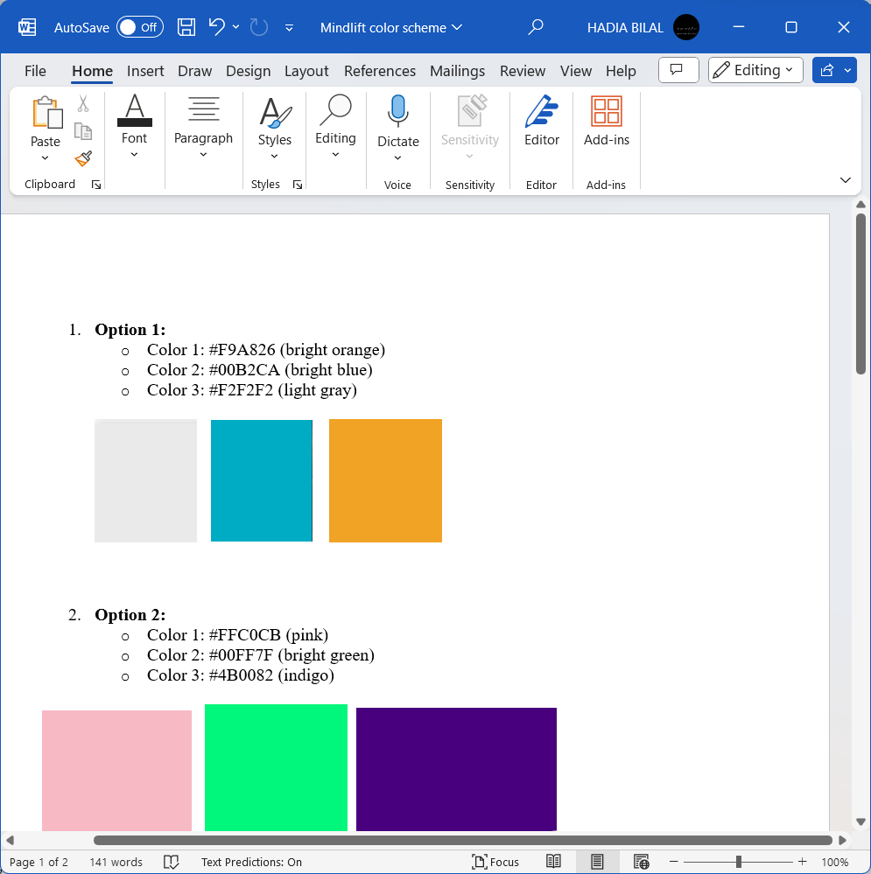

Note: Currently we have only implemented the bright blue color (shown above) along with the colors that are in the logo of Mindlift.

**Flutter Mobile Application:** Flutter was chosen for its cross-platform capabilities, allowing a single codebase to cater to both iOS and Android users. This optimizes development resources and ensures consistent user experience across devices. Flutter also runs on Dart, which is a language like C#, which simplifies a lot of the tediousness of working with C, a language all members of the team are familiar with.

Our decision to use flutter was also in part to Flutters ability to simplify UI creation. With Flutter, making intuitive and easy to use UI is much easier.

**Local AI execution:** Keeping the AI operations local ensures data privacy. Users will be more inclined to be honest and open if they know their sensitive data isn't leaving their device. Keeping the AI local also makes it so that our application does not rely on external servers, so the project will continue to work even without future lack of support.

**User Log Feature:** Allows users to actively record their feelings, fostering a sense of engagement and responsibility towards their mental health journey. We decided on this because it further encourages the use and appreciation of the app's correlation abilities. Beyond being able to just converse with the AI, you can also use the app to directly store your emotions. Using this feature in tandem with chatting with the AI, allows the user to see possible correlations between events from their day and how they are feeling.

**Simple AI Chatbot Design:** Instead of a complex, multifunctional chatbot, we opted for simplicity to ensure its approachable, friendly, and doesn't overwhelm the user. Its primary function is listening and drawing insights, in line with our objective to provide users with a virtual companion. This design choice decreases the broadness of the AI’s knowledge, but allows the AI to run on simpler devices, and to keep its responsibilities strict so it performs as best it can with its resources.

**Trade-offs and Considerations:**

Local AI execution might limit the computational capabilities compared to cloud-based solutions. However, we believe the privacy advantage far outweighs the potential drawbacks. Users will be sharing sensitive information, and we want to make sure they are absolutely assured their secrets are secret.

Simplicity of the AI may sometimes not capture all complexities of a conversation. We accepted this trade-off for the sake of user-friendliness, preventing misinterpretations that can arise from information hallucinations, and resource usage. By creating a simpler, more focused AI, older devices may be able to run the application because of the lowered device resource requirements. Making our AI model simpler also allows us to personally curate training data due to the smaller dataset needed for training, which will keep responses more helpful and reduce the chance of harmful responses.